Lab - View Wireless and Wired NIC Information

1. Objectives

Part 1: Identify and Work with PC NICs

Part 2: Identify and Use the System Tray Network Icons

1. Background / Scenario

This lab requires you to determine the availability and status of the network interface cards (NICs) on the PC. Windows provides a number of ways to view and work with your NICs.

In this lab, you will access the NIC information of the PC and change the status of these cards.

1. Required Resources

* 1 PC (Windows 10 with two NICs, wired and wireless, and a wireless connection)
* A home / small office wireless router, such as a Linksys EA6500

1. Identify and Work with PC NICs

In Part 1, you will identify the NIC types in the PC. You will explore different ways to extract information about these NICs and how to activate and deactivate them.

**Note**: This lab was performed using a PC running on the Windows 10 operating system. You should be able to perform the lab with another Windows operating systems version. However, menu selections and screens may vary.

* 1. Use Network connections.

You will verify which network connections are available.

* + 1. Open the **Network Connections** window by **right-clicking** the Windows **Start** button > **Network Connections**.
    2. The Network Connections window displays the list of NICs available on this PC. Look for your Local Area Connection and Wireless Network Connection adapters in this window.

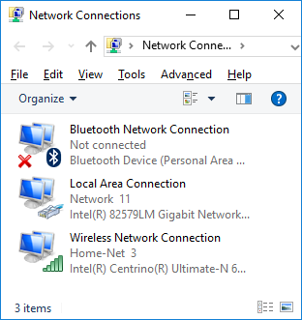

**Note**: Other types of network adapters, such as Bluetooth Network connection and Virtual Private Network (VPN) adapter, may also be displayed in this window.

* 1. Work with your wireless NIC.

Verify the wireless network connection settings.

* + 1. Select the **Wireless Network Connection** option. Right-click on it to display a drop-down list. The first option displays if your wireless NIC is enabled or disabled. Currently, this NIC is enabled which is why the Disable option is displayed. If your wireless NIC is disabled, you will have an option to **Enable** it.



* + 1. Click **Status** to open the Wireless Network Connection Status window.

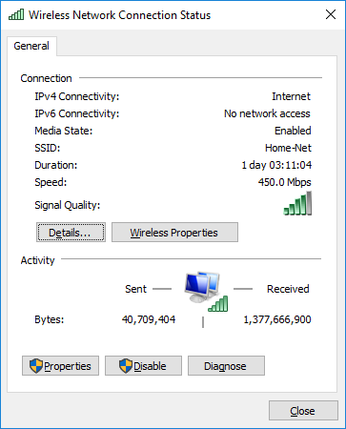

What is the Service Set Identifier (SSID) for the wireless router of your connection?

_____SYSU-SECURE______

What is the speed of your wireless connection?

_____72.2Mbps______

* + 1. Click **Details** to display the Network Connection Details window.

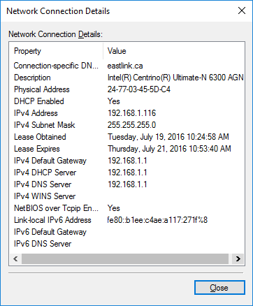

What is the MAC address of your wireless NIC?

_____98-22-EF-41-5C-DD______

* + 1. Open a command window prompt and type **ipconfig /all**.

C:\Users\Bob> **ipconfig /all**

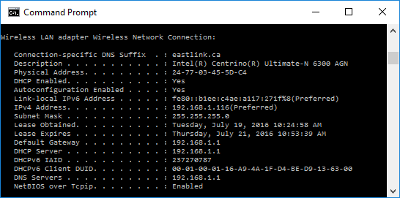

Notice the information displayed is similar to the Network Connection Details window information. When you have reviewed the details, click **Close** to return to the Wireless Network Connection Status window.

* + 1. Return to the Wireless Network Connection Status window. Click **Wireless Properties** to open the **Wireless Network Properties** window of the Home-Net network.

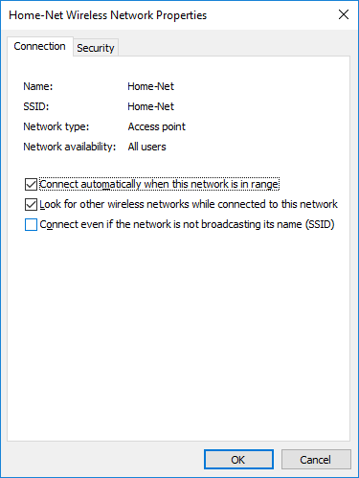

* + 1. You should always use wireless security whenever available. To verify (or configure) the wireless security options click on the **Security** tab.

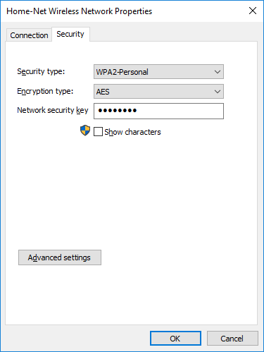

The window displays the type of security and encryption method enabled. You can also enter (or change) the security key in this window. Close all windows.

* 1. Work with your wired NIC.

We will now verify the wired network connection settings.

* + 1. Open the **Network Connections** window by right-clicking Windows **Start** > **Network Connections**.
    2. Select and right-click the **Local Area Connection** option to display the drop-down list. If the NIC is disabled, enable it.

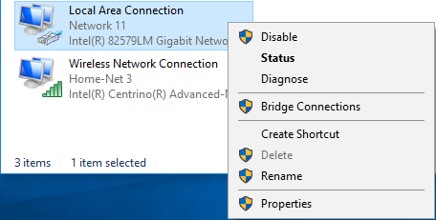

* + 1. Click the **Status** option to open the Local Area Connection Status window. This window displays information about your wired connection to the LAN.

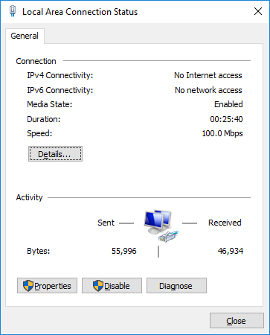

* + 1. Click **Details…** to view the address information for your LAN connection.

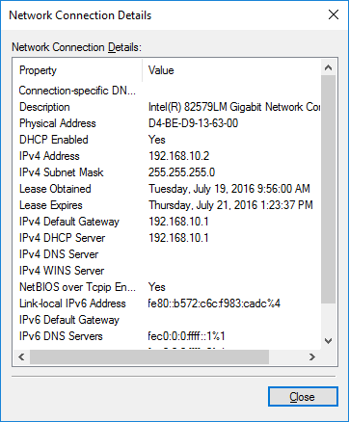

* + 1. Open a command window prompt and type **ipconfig /all**. Find your Local Area Connection information and compare this with the information displayed in the Network Connection Details window.

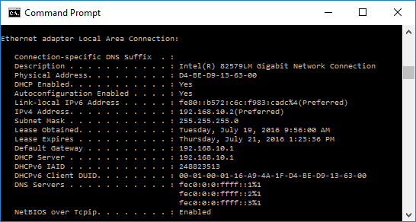

* + 1. Close all windows on your desktop.

1. Identify and Use the System Tray Network Icons

In Part 2, you will use the network icons in your system tray to display the networks available on the network.

* 1. Use the Wireless Network icon.
     1. The bottom right-hand corner of the Windows 10 screen contains the system tray. Move your mouse to display the system tray as shown.



**Note**: If your wired network is enabled, a different network icon () is displayed in the system tray.

* + 1. In this example, the 3rd icon from the left is the wireless network icon. If you hover over it, it displays the currently connected networks.

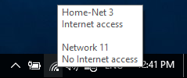

* + 1. Click the wireless network icon, and it displays the wired and wireless network SSIDs that are in range of your wireless NIC.

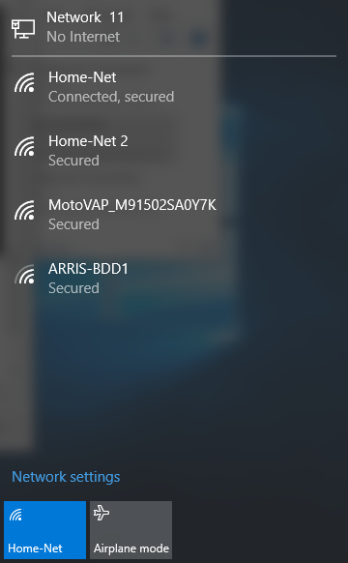

* + 1. Right-click the wireless network icon, and it displays a troubleshooting option and to open the Network and Sharing Center window.

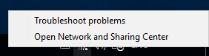

* + 1. Click on the **Open Network and Sharing Center** option.

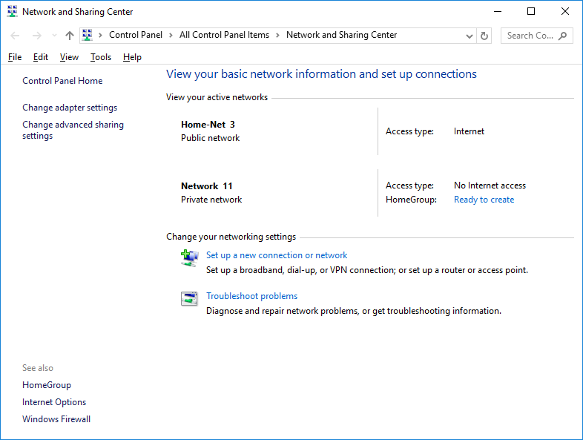

* + 1. The Network and Sharing Center is a central window that displays information about the active network or networks, the network type, the type of access.

1. Reflection

Why would you activate more than one NIC on a PC?

_______________________________________________________________________________________